DOCUMENT SCANNER APP
@CREATIVITY THINK (9483175986/7019689991)

ABSTRACT:
Document Scanner App is a web application designed for offices, schools, and home use to scan and manage documents efficiently. Users can upload images or documents, extract text data using OCR, organize files, and view analytics dashboards. Administrators moderate uploads, review extracted data, export logs, and monitor analytics dashboards. The backend uses Django and Django Rest Framework for secure data handling and processing, while the frontend leverages React, Dropzone, and Tesseract OCR for interactive scanning and text extraction. The system ensures efficient document management, accurate text extraction, and administrative oversight..

INTRODUCTION OF THE PROJECT:
Managing physical and digital documents requires accurate scanning, text extraction, and structured organization. Document Scanner App provides users with the ability to upload and scan images, extract text using OCR, organize scanned documents, and track activities via dashboards. Administrators moderate uploads, review extracted data, export logs, and monitor analytics for operational insights. Django and Django Rest Framework handle backend services including storage and processing, while React, Dropzone, and Tesseract OCR provide a responsive frontend. The platform improves document handling efficiency and ensures accurate text extraction for users..

PROJECT OBJECTIVES:

• Enable users to upload and scan documents/images
• Extract text data accurately using OCR
• Organize scanned documents for easy retrieval
• Provide dashboards for document management and analytics
• Allow administrators to moderate uploads and review data
• Export logs and reports for administrative purposes
• Improve efficiency in document handling and management

PROBLEM OF THE STATEMENT:
Document management, especially involving physical paperwork, is time-consuming and prone to errors. Users and organizations require a platform to digitize documents, extract text efficiently, and organize files. Document Scanner App addresses these challenges by providing a web-based solution where users can upload, scan, extract text via OCR, and organize documents while administrators can moderate uploads, review data, export logs, and monitor analytics dashboards. This ensures efficient, accurate, and trackable document processing..

MOTIVATION OF THE PROJECT:
• Streamline document scanning and digitization
• Enable accurate text extraction using OCR
• Facilitate document organization and retrieval
• Provide administrative oversight and moderation
• Improve efficiency in document management for offices and institutions

BLOCK DAIGRAM OF PROJECT:

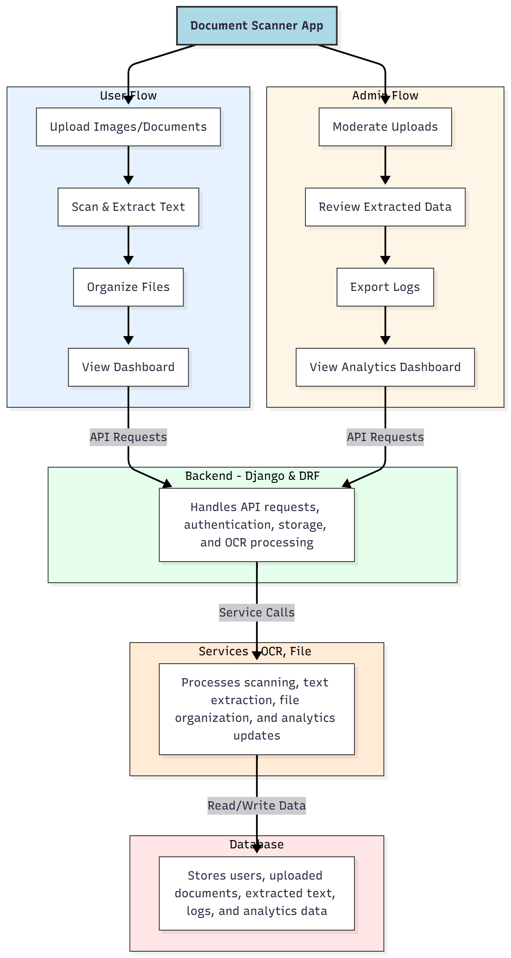

WORKING OF THE PROJECT:
Users upload images or documents, scan and extract text using Tesseract OCR, organize scanned files, and view dashboards for activity summaries. The backend handles API requests, authentication, storage, and OCR processing. Services manage text extraction, file organization, and dashboard analytics. Administrators moderate uploads, review extracted data, export logs, and monitor analytics dashboards. This workflow ensures accurate document digitization, efficient organization, and administrative oversight..

SOFTWARE REQUIREMENT:
- Backend:
  - Python 3.x
  - Django
  - Django REST Framework
  - SQLite/PostgreSQL
- Frontend:
  - Node.js and npm
  - React.js
  - Axios
- Development Tools:
  - Visual Studio Code
  - Postman (for testing APIs)
  - Git/GitHub (for version control)
- Server/Deployment (Optional):
  - Gunicorn, Nginx, or Heroku/AWS for hosting

ADVANTAGES OF THE PROJECT:

• Efficient document scanning and digitization
• Accurate text extraction using OCR
• Organized file management and retrieval
• Administrative moderation and analytics
• Exportable logs and reports
• Improved document management efficiency
• Centralized user and admin dashboard
• Secure handling of uploaded files

APPLICATIONS OF THE PROJECT:
• Office document digitization
• School and educational record scanning
• Home document organization
• OCR-based text extraction for files
• Administrative monitoring and moderation
• Analytics reporting for document usage
• Exportable logs for compliance
• Secure digital document management

REFERENCES:

- Django REST Framework Documentation — Django Software Foundation. Django Documentation. Available: https://docs.djangoproject.com/
- Django REST Framework. DRF Documentation. Available: https://www.django-rest-framework.org/
- React. React Official Documentation. Available: https://reactjs.org/docs/getting-started.html
- Redux. Redux Documentation. Available: https://redux.js.org/introduction/getting-started
- PostgreSQL Global Development Group. PostgreSQL Documentation. Available: https://www.postgresql.org/docs/
- MySQL. MySQL Reference Manual. Available: https://dev.mysql.com/doc/
- Git. Git Documentation. Available: https://git-scm.com/doc
- Node.js. Node.js Documentation. Available: https://nodejs.org/en/docs/
- Axios. Axios Documentation. Available: https://axios-http.com/docs/intro
- Socket.io Documentation – https://socket.io/docs/

